Lesson 6 Demo 3: Install Mirantis Secure Registry

This section will guide you to:

* Install and set up Mirantis Secure Registry (MSR)

This lab has four subsections, namely:

1. List the insecure registries which you are going to run while running MSR
2. Get the MSR installation command from Admin Settings in MKE
3. Run the MSR installation command in Docker CLI
4. Verify that the MSR is successfully installed

**Step 1:** List the insecure registries which you are going to run while running MSR

* For **Ubuntu 14.x**, open the */etc/default/docker* file in your terminal, and edit the *DOCKER_OPTS* parameter

*DOCKER_OPTS="--insecure-registry* ***<registry.example.com>*** *-H tcp://127.0.0.1:2375 -H unix:///var/run/docker.sock"*

**Note:** Replace ***<registry.example.com>*** with the **private IP address of worker1 node**, where you are going to install MSR

* For **Ubuntu 16.x**or**CentOS**, edit or create */etc/docker/daemon.json,* and add this to the file:

*{*

*"insecure-registries" : ["registry.example.com"]*

*}*

**Note:** Replace *registry.example.com* with the **private IP address of worker1 node**, where you are going to install MSR

* Restart Docker Daemon with the following command:

*sudo service docker restart*

**Step 2:** Get the MSR installation command from Admin Settings in MKE

* In MKE, go to **Admin Settings**, and click on **Mirantis Secure Registry**

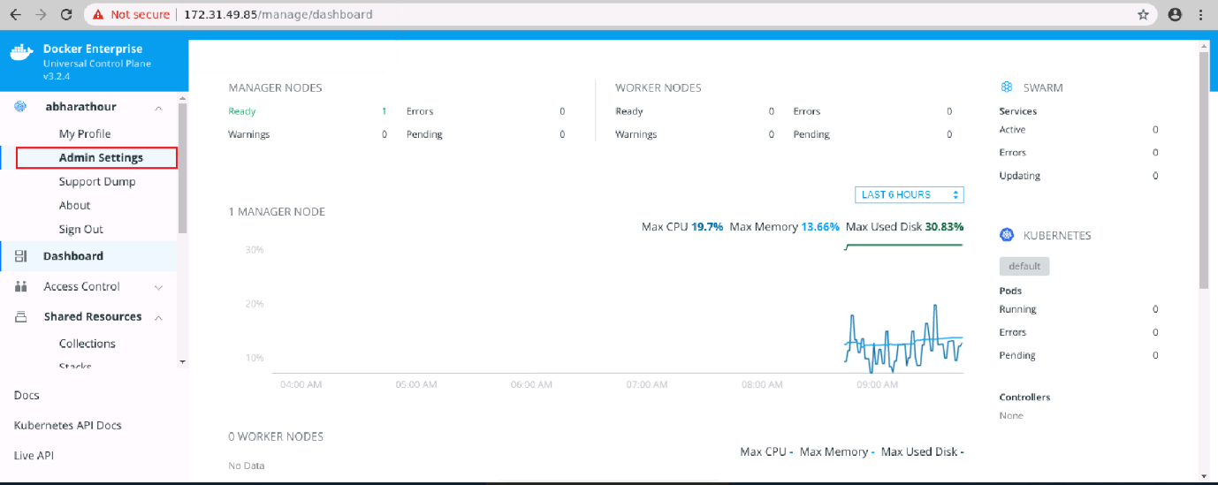

* To create an MSR instance, select a **MKE Node**, tick the **Disable TLS verification for UCP** checkbox, and click on **Copy to Clipboard** to copy the command to install DTR

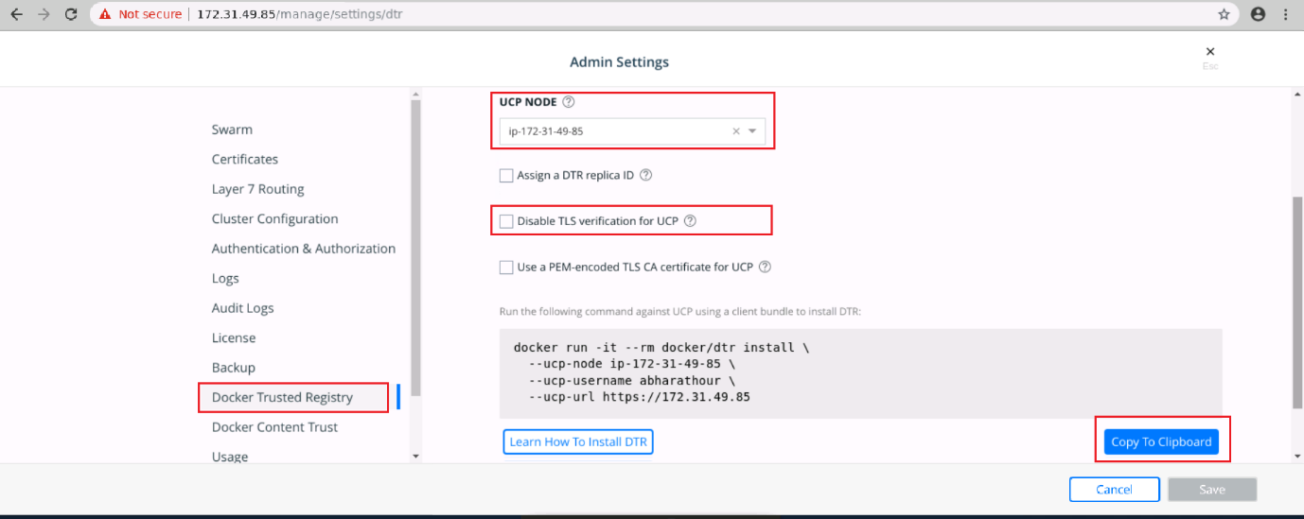

**Step 3:** Run the MSR installation command in Docker CLI

* Open the terminal, and run the copied command. You can also use the following command to install MSR:

*docker run -it --rm docker/dtr install --ucp-node ip-<ip-address> --ucp-username abharathour --ucp-url https://172.31.49.85:436 --ucp-insecure-tls*

**Note:** Replace *<ip-address>* with the **private IP address of worker1 node**

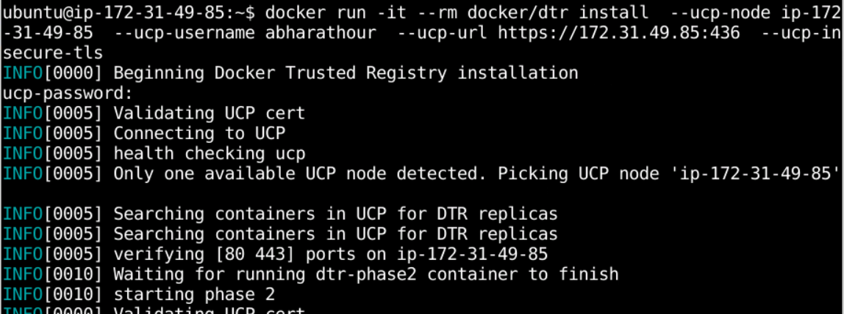

**Step 4:** Verify that the MSR is successfully installed

* Once the installation is complete, navigate to **Admin Setting-> Mirantis Secure Registry** in **MKE Web UI**. You will see the installed MSR IP address
* Go to MSR IP address (172.31.49.85, in this case), and you will see the DTR *Sign in* page

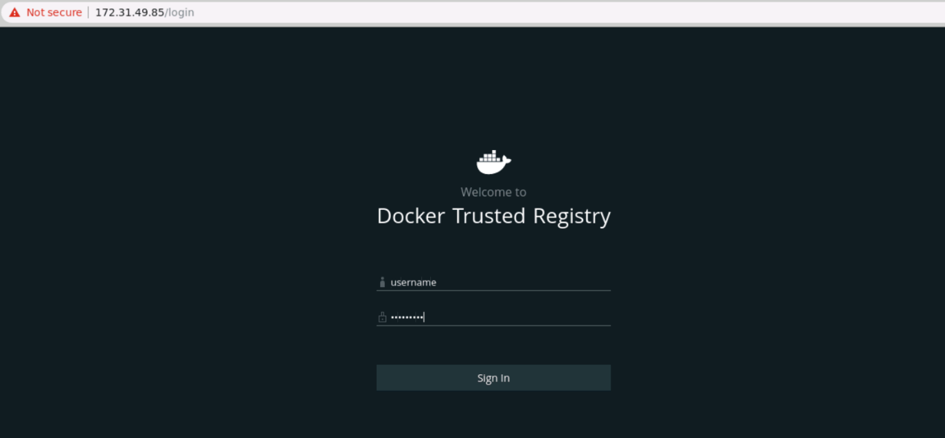

**Note:** For the sign in process, use the same login credentials as of MKE web UI.